**A Mathematical thought experiment — Sin wave curved along exponential function**

From the past few days, a mathematical thought experiment was running within my mind, which I would like to share with you.

**Prerequisite -**

Before I dive into the details and result of thought experiment, I would like to briefly explain you how we plot a mathematical function in x-y plane and also about its alternative interpretation, as it is a prerequisite to understand the thought experiment.

**Understanding the concept of plotting a function in x-y plain : -**  
 Let us consider a function F(x) that we want to plot in x-y plain. Conventionally, we do the following steps.

1. For a particular value let suppose x units , we compute F(x) = y units.
2. Then, we mark point X at distance of x units, on x-axis.
3. Then, we will mark point Y at distance of y units on a line which is perpendicular to x-axis and pass through point X on x-axis.
4. Then will repeat above steps for many more X points, to get full-fledged graph.

**Alternative interpretation of plotting** **a function in x-y plain : -**  
However, there is an another way also to interpret the plotting of F(x) in x-y plain. We can consider x-axis as a function itself, as   
**X-axis → G(x)=0**.  
So, G(x)=0 is a line function which is parallel to and coincide with X-axis and **function F** is plotted with respect to G(x). We can consider **function F** as function of **length of G(x)** from origin to point X on G(x), such that **function F** will become **F(Length(G(x)))**. Since **function** G(x)=0, we can deduct that **Length(G(x))=x units** and therefore **F(Length(G(x))) = F(x)**.  
 Now, we can plot a point Y of **F(Length(G(x)) = y units**, with respect to point X on G(x)=0, such that point Y is at distance of y units on a line which is perpendicular to tangent at point X and pass through point X on G(x)=0 (x-axis).

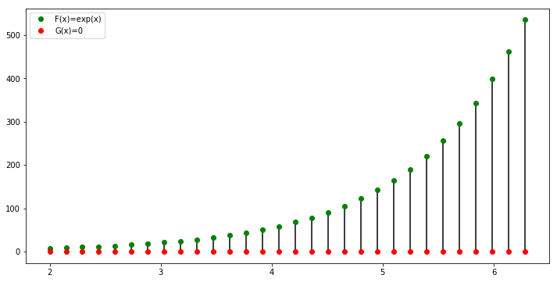**Figure 1 -> Function F(x)=exp(x) and Function G(x)=0**

**A Thought Experiment-**

**Details of Thought Experiment**   
As I discussed in above section, plotting a graph of **F(x)** in **x-y plain** can be interpreted as plotting a **function F** with respect to **function G(x)**, where **F** is a function of **Length(G(x))** which is equal to **x** because **G(x)=0**.   
(In case an explanation is needed, why **Length(G(x))=x, if G(x)=0**, I can help)

In the above section we mentioned G(x)=0 as constant function of line on x-axis.Now consider the following scenario.  
1. G(x)!=0 but G(x) is non linear and complex function.   
2. Function F(Length(G(x))) is a function of G(x)’s length, but since G(x) is not a constant function (G(x)!=0), therefore Length(G(x))!=x units, but a complex non linear function.  
3. value of F(Length(G(x))) is plotted on a line which is perpendicular to tangent at point (x,G(x)).

Let me take an example to get a deeper understanding of above scenario.

**An Example**Let us take an example,

